Compte Rendu TP JavaScript

Exo 1 :
<!DOCTYPE html>
<html>

<head>
<title>Mon premier script JavaScript !

</title>
</head>

<body>
<h3>Ceci est un document HTML habituel.</h3>
<script type="text/javascript" language="javascript1.2">
document.write("<i>Ceci est une partie de texte écrite" + " avec JavaScript" + "</i><br>");
var now = new Date();
document.write("Aujourd'hui, nous sommes le " + now);
</script>
<h3>Nous sommes de retour au code HTML habituel.
</h3>
</body>

</html>
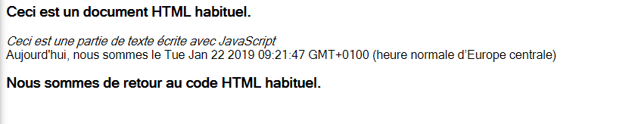

1.2.1
<html>

<head>
<title>Mon premier script JavaScript !

</title>
</head>

<body>
<h3>Ceci est un document HTML habituel. Script Externe</h3>
<script src="main.js">

</script>
<h3>Nous sommes de retour au code HTML habituel.</h3>
</body>

</html>
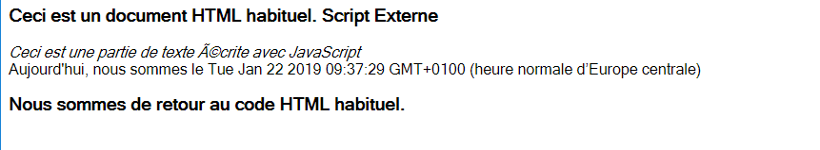

1.2.2
<html>

<head>
<script language="JavaScript"> var now = new Date();
function calculer() {alert("Nous somme le " + now);}</script>
</head>

<body>
<form><input type="submit" name="bt1" value="Quelle heure est il ?" onClick="calculer();"></form>
</body>
</html>
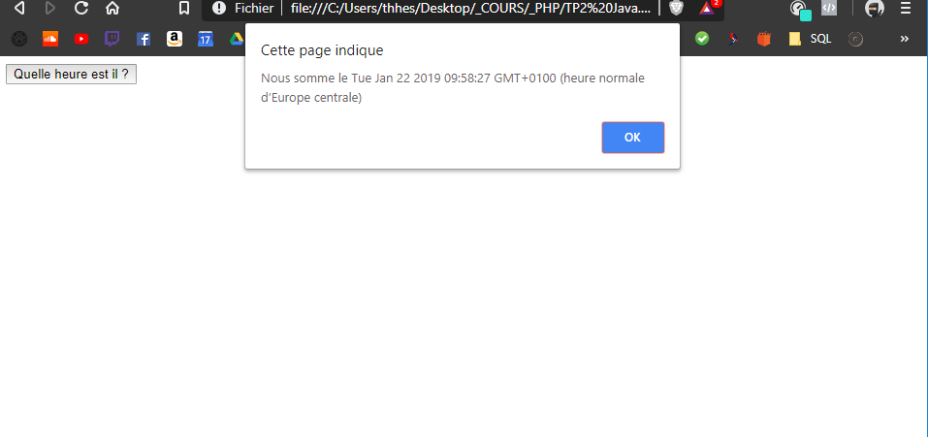
1.2.3
<html>

<head>
<script language="JavaScript">
function heure() {
var now = new Date();
alert("Nous sommes le " + now);
}
</script>
</head>

<body>Clique <a href="javascript:void(heure())">ici</a> pour savoir l'heure</body>

</html>

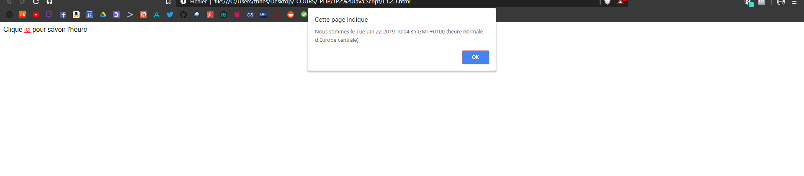

Exo 2.1.32

<!DOCTYPE html>
<html>

<head>
<meta charset="UTF_8" />
<script type="text/javascript" language="javascript1.2">
var prixHT = 150;
prixTTC = 0;
if (prixHT == 0) alert("donner un prix HT !");
elseprixTTC = prixHT * 1.20;
document.write("Prix HT = " + prixHT + "<br>");
document.write("Prix TTC = ", prixTTC, "<br>");
</script>
</head>

<body>

</body>

</html>
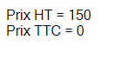

2.1.33
<!DOCTYPE html>
<html>

<head>
<meta charset="UTF_8" />
<script type="text/javascript" language="javascript1.2">
var age = 0;
age = prompt("Donnez votre âge : ", "");
if (age <= 0) alert("Cela n'a pas de sens !");
else if (age <= 13) alert("Vous êtes encore bien trop jeune ...");
else if (age < 18) alert("Désolé, vous êtes encore mineur(e)");
else if (age < 25)
alert("Vous êtes déjà majeur(e) !");
else
alert("Ne vous vieillissez donc pas !");
</script>

</head>

<body>

</body>

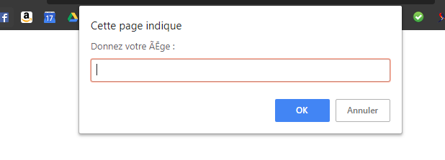
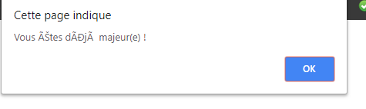
</html>

Exo2.1.50

<!DOCTYPE html>
<html lang="fr">

<head>
<meta charset="UTF-8"/>
<script type="text/javascript" language="javascript1.2">
function alerte() {
alert("Ceci est un message d'alerte !");
}
</script>
</head>

<body>
<form><input type=button value="Méthode alert()" onclick="alerte()"></form>
</body>

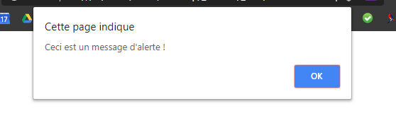
</html>



Exo 2.1.53

<!DOCTYPE html>
<html>

<head>
<title>Confirmation</title>
<meta charset="UTF-8"/>
</head>

<body>
<script type="text/javascript" language="javascript1.2">
var a = confirm("Cliquer sur OK ou Annuler");
if (a == true) {
alert("Vous avez cliqué sur OK");
} else {
alert("Vous avez cliqué sur Annuler");
}
</script>
</body>

</html>




Exo 2.1.56
<!DOCTYPE html>
<html>

<head>
<title>Invite</title>
<meta charset="UTF-8"/>
</head>

<body>
<script type="text/javascript" language="javascript1.2">
var prenom = prompt("Saisir votre prenom", "Votre prenom ici");
document.write("<h2>Bonjour " + prenom + "</h2>");
</script>
</body>

</html>

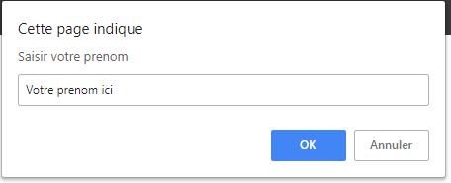

Exo 2.2
<!DOCTYPE html>
<html>

<head>
<title>Invite</title>
<meta charset="UTF-8"/>
<script type="text/javascript" language="javascript1.2">
var heure = prompt("Saisir l'heure", "Heure");
var minutes = prompt("Saisir les minutes", "Minutes");
var secondes = prompt("Saisir Les secondes", "Secondes");
var total = heure*3600 + minutes*60 + secondes*1;
document.write("<h2>le temps total est de " + total + " secondes</h2>");
</script>
</head>

<body>
</body>

</html>
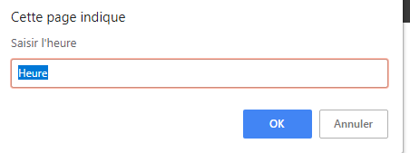

Exo 2.3
<!DOCTYPE <!DOCTYPE html>
<html>

<head>
<meta charset="utf-8" />
<script>
var note = prompt("Quelle est ta note", "Note ?");

if (note < 10) {
document.write("<h2>"+"La note de " + note + " t'accorde la mention " + "ECHEC" + "</h2>");
}

if (note >= 10 && note < 12) {
document.write("<h2>"+"La note de " + note + " t'accorde la mention " + "PASSABLE" + "</h2>");
}

if (note >= 12 && note < 14) {
document.write("<h2>"+"La note de " + note + " t'accorde la mention " + "ASSEZ BIEN" + "</h2>");
}
if (note >= 14 && note < 16) {
document.write("<h2>"+"La note de " + note + " t'accorde la mention " + " BIEN" + "</h2>");
}
if (note >= 16) {
document.write("<h2>"+"La note de " + note + " t'accorde la mention " + "TRES BIEN" + "</h2>");
}
</script>

<body>

</body>

</html>

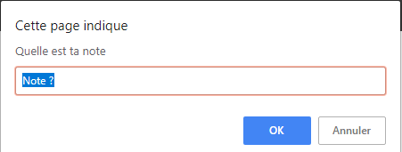

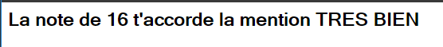

Ex 3.1,36
<!DOCTYPE <!DOCTYPE html>
<html>

<head>
<meta charset="utf-8" />
<meta http-equiv="X-UA-Compatible" content="IE=edge">
<title>Hesters Théophile</title>
<meta name="viewport" content="width=device-width, initial-scale=1">
<link rel="stylesheet" type="text/css" media="screen" href="main.css" />
<script type="text/javascript" language="javascript1.2">
document.write("Table des carrés<br>");
for (var i = 1; i <= 15; i++) {
document.write("i = " + i + " i<sup>2</sup> = " + i * i + "<br>");
}
</script>
</head>

<body>

</body>

</html>
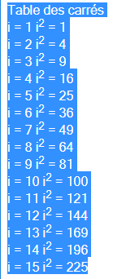

Ex 3.1.37

<!DOCTYPE html>
<html>

<head>
<meta charset="utf-8" />
<meta http-equiv="X-UA-Compatible" content="IE=edge">
<title>HEsters Théophile</title>
<meta name="viewport" content="width=device-width, initial-scale=1">
<link rel="stylesheet" type="text/css" media="screen" href="main.css" />
<script type="text/javascript" language="javascript1.2">
function hasard(N) {
return Math.floor(Math.random() * N) + 1;
}
document.write("Tableau de 10 nombres au hasard<br>");
max = prompt("Nombres au hasard de 1 à ", "10");
tab = new Array(10);
for (var i = 0; i < 10; i++) tab[i] = hasard(max);
for (var i = 0; i < 10; i++) document.write("tab [" + i + "] = " + tab[i] + "<br>");
</script>
</head>

<body>

</body>

</html>
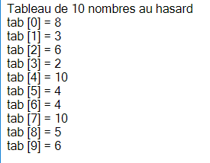

Ex 3.1.39
<!DOCTYPE <!DOCTYPE html>
<html>

<head>
<meta charset="utf-8" />
<meta http-equiv="X-UA-Compatible" content="IE=edge">
<title>Hesters Théophile</title>
<meta name="viewport" content="width=device-width, initial-scale=1">
<link rel="stylesheet" type="text/css" media="screen" href="main.css" />
<script type="text/javascript" language="javascript1.2">
function hasard(N) {
return Math.floor(Math.random() * N) + 1;
}
max = prompt("Nombres au hasard de 1 à ", "6");
document.write("<h2>Tableau de nombres entre 1 et " + max + " tirés au hasard, jusqu'à obtenir " + max +
"</h2>");
tab = new Array(10 * max);
a = hasard(max);
tab[0] = a;
i = -1;
while (a != max) {
i++;
a = hasard(max);
tab[i] = a;
}
i++;
document.write(max + ' a été obtenu au ' + i + 'ème tirage <br>');
i = 0;
while (tab[i] != null) {
document.write("tab[", i, "] = ", tab[i], " --- ");
if ((i + 1) % 5 == 0) document.write("<br>");
i++;
}
</script>

</head>

<body>

</body>

</html>
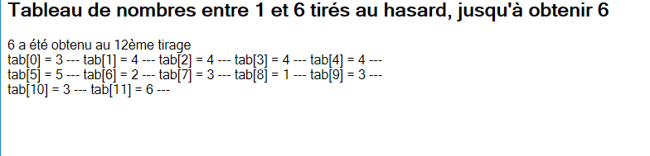
Ex 3.2
<!DOCTYPE <!DOCTYPE html>
<html>

<head>
<meta charset="utf-8" />
<meta http-equiv="X-UA-Compatible" content="IE=edge">
<title>Hesters Théophile</title>
<meta name="viewport" content="width=device-width, initial-scale=1">
<link rel="stylesheet" type="text/css" media="screen" href="main.css" />
<script type="text/javascript" language="javascript1.2">
document.write("1 to 21<br>");
for (var i = 1; i <= 21; i++) {
if ( i %2 == 1)
{
document.write("i = " + i + "<br>");
}

}
</script>
</head>

<body>

</body>

</html>
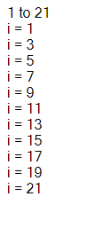

Ex 3.3
<!DOCTYPE <!DOCTYPE html>
<html>

<head>
<meta charset="utf-8" />
<meta http-equiv="X-UA-Compatible" content="IE=edge">
<title>Hesters Théophile</title>
<meta name="viewport" content="width=device-width, initial-scale=1">
<link rel="stylesheet" type="text/css" media="screen" href="main.css" />
<script type="text/javascript" language="javascript1.2">
var i = 1;
var c = 1;
for ( i = 3; i <= 21; i ++)
{
if(i%2 != 0)
{
c = c +1/i;
}
}
document.write("la somme est " + c);
</script>
</head>

<body>

</body>

</html>
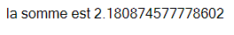

Ex 3.5

<!DOCTYPE html>
<html>
<head>
<meta charset="utf-8" />
<meta http-equiv="X-UA-Compatible" content="IE=edge">
<title>Hesters Théophile</title>
<meta name="viewport" content="width=device-width, initial-scale=1">
<link rel="stylesheet" type="text/css" media="screen" href="main.css" />
<script type="text/javascript" language="javascript1.2">
var tabl = 0;
var i = 0;
tabl = prompt("Tu veux la Table de : ", "?");
document.write("Table de :" + tabl+"</br>");
for(var cpt = 0; cpt <=10 ; cpt++)
{
i = tabl * cpt;
document.write(cpt + "x" + tabl + " = " + i +"</br>");
}
</script>
</head>

<body>

</body>

</html>
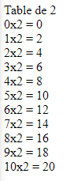

Ex 3.6
<!DOCTYPE <!DOCTYPE html>
<html>

<head>
<meta charset="utf-8" />
<meta http-equiv="X-UA-Compatible" content="IE=edge">
<title>Hesters Théophile</title>
<meta name="viewport" content="width=device-width, initial-scale=1">
<link rel="stylesheet" type="text/css" media="screen" href="main.css" />

<script type="text/javascript" language="javascript1.2">
var tabl = 0;
var i = 0;
tabl = prompt("Tu veux la Table de : ", "?");
document.write("<table border = 1>");
document.write("<td>");
document.write("Table de :" + tabl + "</br>");
document.write("</td>");
document.write("</table>");
for (var cpt = 0; cpt <= 10; cpt++) {
i = tabl * cpt;
document.write("<table border = 1>");
document.write("<td>");
document.write(cpt + "x" + tabl + " = " + i + "</br>");
document.write("</td>");
document.write("</table>");
}
</script>
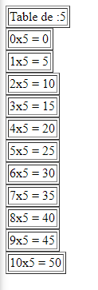
</head>

<body>

</body>

</html>

Ex 4.1.45
<!DOCTYPE <!DOCTYPE html>
<html>

<head>
<script type="text/javascript" language="javascript1.2">
function bonjour(prenom) {
document.write("Bonjour, comment vas-tu ", prenom, " ?<br>");
}

function volumeSphere(rayon) {
return 4 / 3 * Math.PI * Math.pow(rayon, 3);
}

function calculerPrix(PrixUnitaire, NbArticles) {
return PrixUnitaire * NbArticles;
}
</script>
</head>

<body>
<script type="text/javascript" language="javascript1.2">
{
var montant = calculerPrix(150, 4);
document.write("Tu dois payer " + calculerPrix(150, 4) + " euros.<br>");
document.write("Le volume de la sphère de rayon unité est " + volumeSphere(1) + "<br>");
}
</script>
</body>

</html>
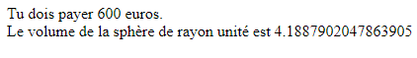

Ex 4.1.47
<!DOCTYPE <!DOCTYPE html>
<html>

<head>
<meta charset="utf-8" />
<meta http-equiv="X-UA-Compatible" content="IE=edge">
<title>Hesters Théophile</title>

<head>
<script type="text/javascript" language="javascript1.2">
function bonjour(nom) {
var ch = "Salut !";
document.write("Au début de la fonction : Bonjour " + nom + "<br>");
nom = "Alain";
document.write("A la fin de la fonction : Bonjour " + nom + "<br>");
}
var prenom = "Jacques";
bonjour(prenom);
document.write("Après appel de la fonction : Bonjour " + prenom + "<br>");
</script>
</head>

</head>

<body>

</body>

</html>
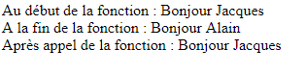

Ex 4.2
<!DOCTYPE <!DOCTYPE html>
<html>

<head>
<meta charset="utf-8" />
<meta http-equiv="X-UA-Compatible" content="IE=edge">
<title>Hesters Théophile</title>
<script>
function table_mult(N) {
document.write("<table border = 1>");
document.write("<td>");
document.write("Table de :" + N + "</br>");
document.write("</td>");
document.write("</table>");

for (var cpt = 0; cpt <= 10; cpt++) {
i = N * cpt;
document.write("<table border = 1>");
document.write("<td>");
document.write(cpt + "x" + N + " = " + i + "</br>");
document.write("</td>");
document.write("</table>");
}
}
</script>
</head>

<body>
<script type="text/javascript" language="javascript1.2">
var N = 0;
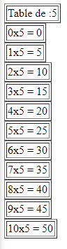
var i = 0;
N = prompt("Tu veux la Table de : ", "?");
table_mult(N);
</script>
</body>
</html>

Ex 4.3
<!DOCTYPE <!DOCTYPE html>
<html>

<head>
<meta charset="utf-8" />
<meta http-equiv="X-UA-Compatible" content="IE=edge">
<title>Hesters Théophile</title>
<script>
function table_mult(N) {
document.write("<table border = 1>");
document.write("<td>");
document.write("Table de :" + N + "</br>");
document.write("</td>");
document.write("</table>");

for (var cpt = 0; cpt <= 10; cpt++) {
i = N * cpt;
document.write("<table border = 1>");
document.write("<td>");
document.write(cpt + "x" + N + " = " + i + "</br>");
document.write("</td>");
document.write("</table>");
}
}
</script>
</head>

<body>
<script type="text/javascript" language="javascript1.2">
var N = 0;
var i = 0;
for (N = 1; N <= 10; N++) {
table_mult(N);
}
</script>
</body>

</html>

